***ts Produc***

***Motion t***

***Midwes***



Midwest Motion Products

P/N: MMP LA3-12V- 5-A-SP-100

## TECHNICAL FEATURES:

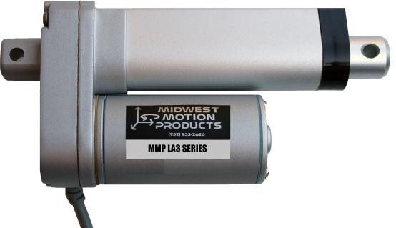

* HIGH FORCE DESIGN
* ENHANCED CORROSION RESISTANCE
* ALUMINUM OUTER TUBE
* ZINC ALLOY HOUSING
* NON-ROTATING ALUMINUM INNER TUBE
* POWDERED METAL GEARS
* PERMANENTLY LUBRICATED

|  |  |
| --- | --- |
| Gear Ratio | 5 : 1 |
| Input Voltage | 12 VDC |
| Load Capacity (Force) | 45 Lbs. (200N) |
| Static Load | 517 Lbs. (2300N) |
| Stroke Length | 4.0" (100mm) |
| Speed @Full Load | 2.0”/sec |
| Clevis Ends | 8mm dia. Mounting Holes on each end |
| Screw Type | ACME Screw |
| Duty Cycle | Max Recommended Duty = 60% |
| Operating Temp Range | -26ºC ~ 65ºC (-15ºF ~ 150ºF) |
| Limit Switches | Built-in, for both ends of travel (factory preset) |
| IP Grade | IP65 |

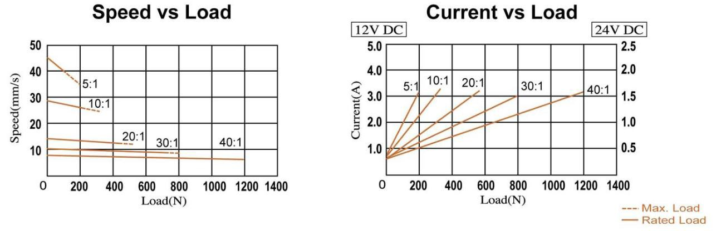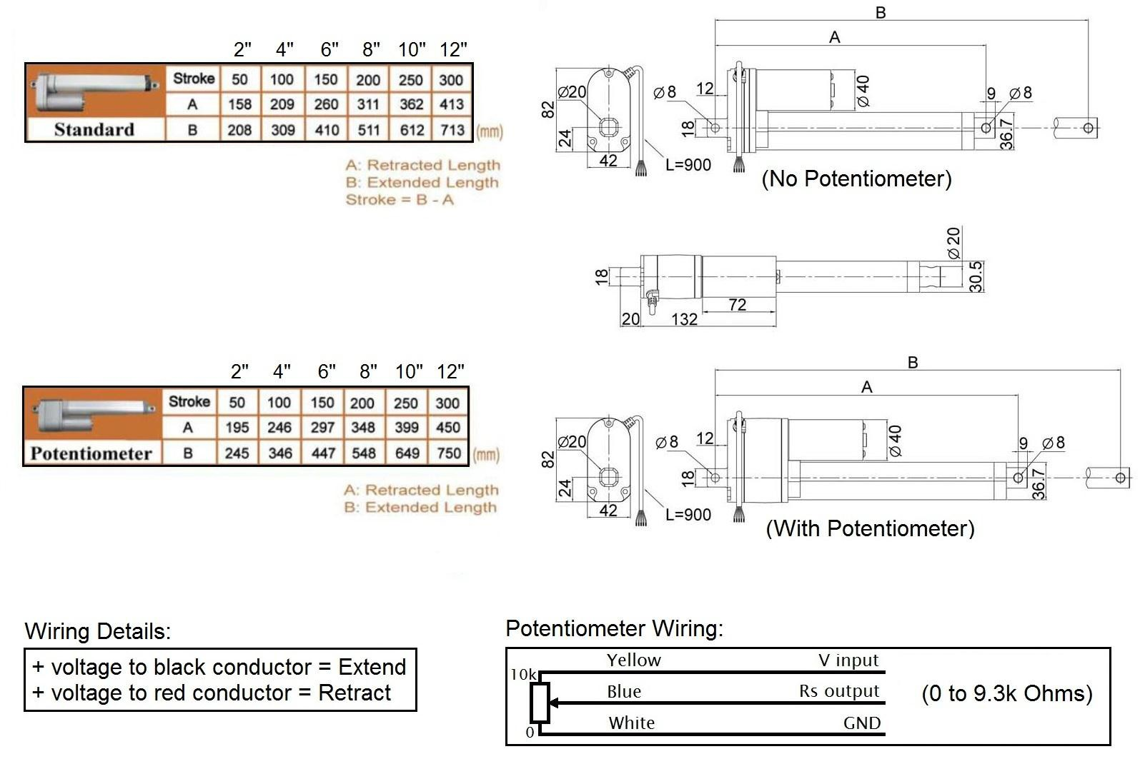

Midwest Motion Products