DAKSH ELECTRONICS

PLC, AC/DC/Servo Drives Panels, HMI, Soft Starter, Power & control Panels,
Contact us: 187, Gali No. 6, Rajiv Colony, Narela, Delhi-110040, India
Telephone No.: 011-27283404, +91-9873571358, +91-9716835646
Website: www.unicorncontrol.com, Mail id: control.unicorn@gmail.com

AC Drive REPAIR Services

DAKSH ELECTRONICS Provides services of Sales & Repairing in Industrial Automation Products of MITSUBISHI, SIEMENS, DANFOSS, YASKAWA, ABB etc. AC/DC Drives, High Frequency Drives, PLC, HMI, MMI, and TOUCH SCREEN, Power Supplies, SMPS, PID etc. We are offering the lowest price in the market for repairing. It is trades and repairs all kinds of Industrial Electronics and Electrical instruments, all at one junction. Based on the strong technical background, we design frequency inverters according to world’s highest standards. Top level R&D team & strict double Quality Check enables us to, so waiting for your valuable inquiry.
Our impressive PLC repair test wall contains complete PLC systems from a variety of manufacturers. We test PLCs the same way you use them, so you can be confident in a job done right.
Services for all industrial items
Repairing:
We provide repair service in the field of industrial electronics
instruments and PCBs as mention below.
• AC variable frequency drives (VFD)
• DC Drive
• Servo Drive
• Soft starter
• Stepper Drive
• Spindle Drive
• SMPS
• Temperature Controller
• PID Controller
Drives frequently repair by us:
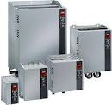 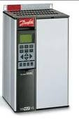\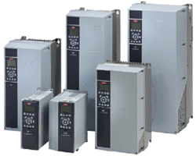
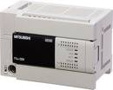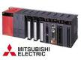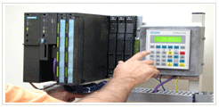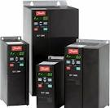

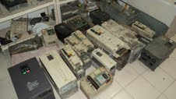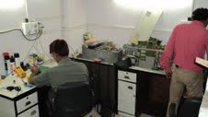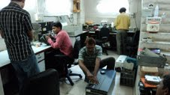

OUR PRODUCTS
SUPPLIER OF REPUTED BRANDS

OUR PRODUCTS:-
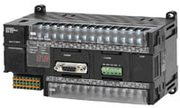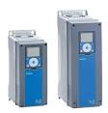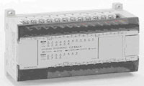
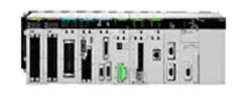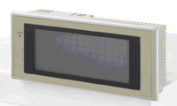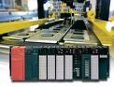
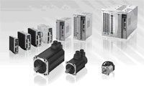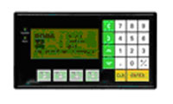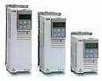

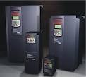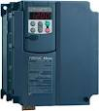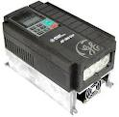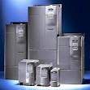

WE REPAIR ALL MAKE INDUSTRIAL PRODUCTS
AC DRIVE, SERVO DRIVE, TOUCH SCREEN, PLC

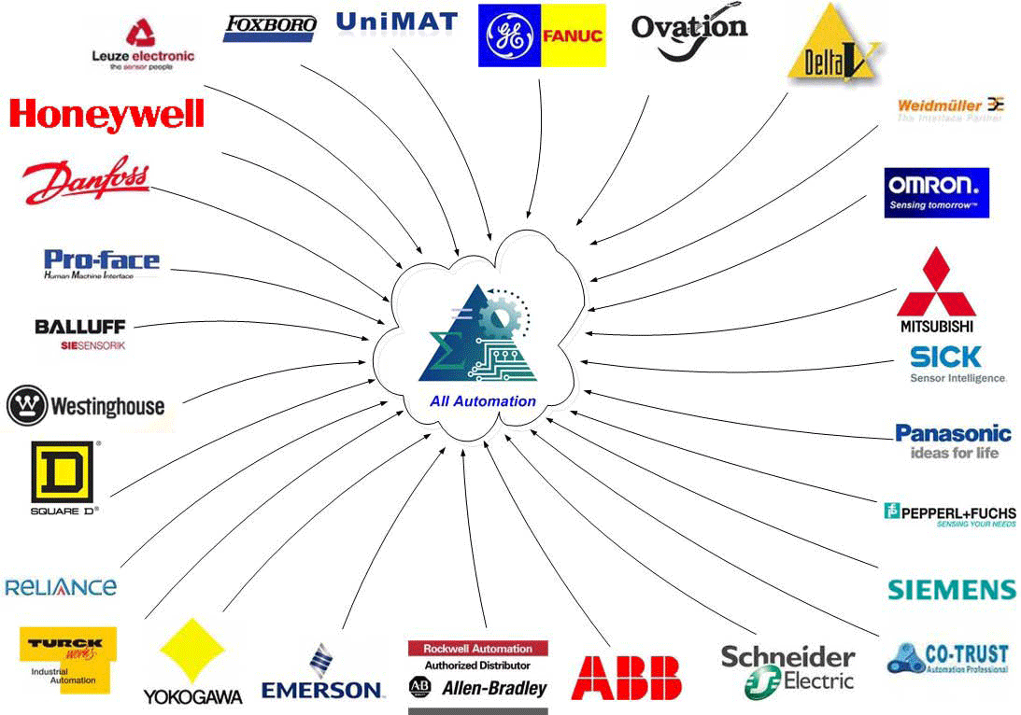

OUR SATISFIED CLIENTS

- ARB BEARINGS LTD
- BHARAT ELECTRONICS LTD
- ECE INDUSTRIES LTD
- SATYAM PAPER LTD
- CAPARO INDIA
- JAI BHARAT SARIA SAMBHALKA
- UNIFEB LTD SOENPAT
- KOHINOOR FOODS LTD
- JAGAN LAMPS LTD SONEPAT
- AASHIRWAD FOODS LTD
- PICL LTD FARIDABAD
- PIPL SITARGANJ
- METEZLER PVT LTD DAHRUHERA
- KALINGA CABELS SONEPAT
- CENTURIAN CABLES DELHI
- STERLLING TOOLS LTD
- BAJAJ MOTORS LTD Binola
- L&T LTD
- Jaypee Group
- Delhi Metro Rail Corporation

Regards
R.K. Sharma
(Sr. Executive)
Contact no. 9873571358

